
K&M Tire

CDSM
Version 1.0
03/23/2021

Document Number:
Contract Number:

Table of Contents
1. K&M Tire 4
1.2 Important Company Information 6
2. Car Dealer Sales Manager Manual Introduction 8
3. Welcome 9
4. Providing Training, Leadership and Direction to produce maximum unit growth 10
4.1 Conduct CDS employee evaluations 10
4.2 Visit and make sales calls with the CDS or OSR at least once a month 10
4.3 Provide direction to the CDS on a daily, weekly and monthly basis 10
4.4 Be knowledgeable of and promote the products K&M has to offer. 11
4.5 Be knowledgeable of and promote the programs K&M has to offer 11
4.6 The CDSM needs to have working knowledge of K&M’s various vendor and partner programs. 11
4.7 Be knowledgeable of and promote K&M’s Weblink 2.0 11
4.8 Work towards the BestOne motto of: give every customer a reason to smile (outstanding customer service) 12
4.9 Make it easy and convenient to do business with K&M Tire. 12
4.10 Evaluate and establish territories 12
4.11 Promote a team environment 13
4.12 Responsible for managing and resolving conflict in the work environment by using the company Values as a guide. 13
4.13 Assure that competent, good quality work is being done. 13
4.14 Present a clean, neat, professional appearance. 14
4.15 Work closely with K&M management 14
4.16 Make good business decisions to help K&M be successful now and in the future. 15
4.17 Must support company goals 15
4.18 Manage CDS schedules and PTO 15
4.19 Manage CDS expenses 15
4.20 OE Connection 15
4.21 Sending out valuable emails to OSR & CDS to provide a clear goal / message. 15
4.22 Request current active AMI Dealer List & KM Feed info from IT – Monthly 15
4.23 Use the customer list to look for car dealers not properly categorized every 1 – 6 months. 16
5. Frequently Asked Questions 17
Appendix Revision History Tracking 18

- List of Figures
No table of figures entries found.

- List of Tables
Table 1 - Support Points of Contact 115
Table 2 - Acronyms 119
Table 3 - Glossary 121
Table 4 - Referenced Documents 122
Table 5 - Approvals 124
Table 6 - Revision History Tracking 127

K&M Tire
Video about K&M Tire
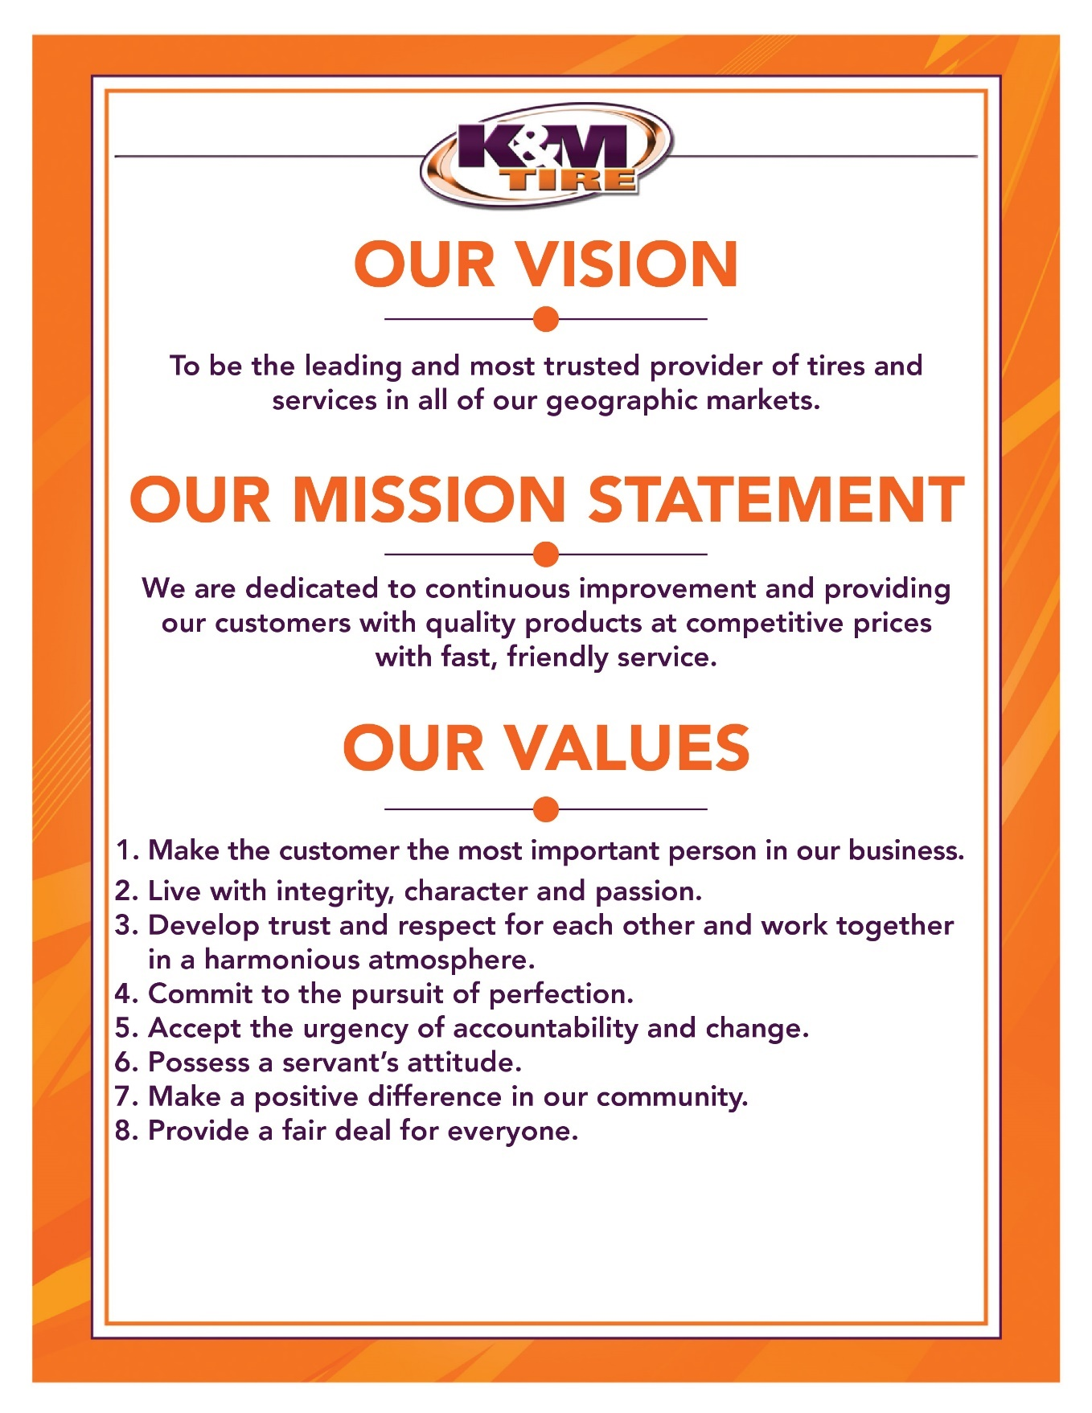

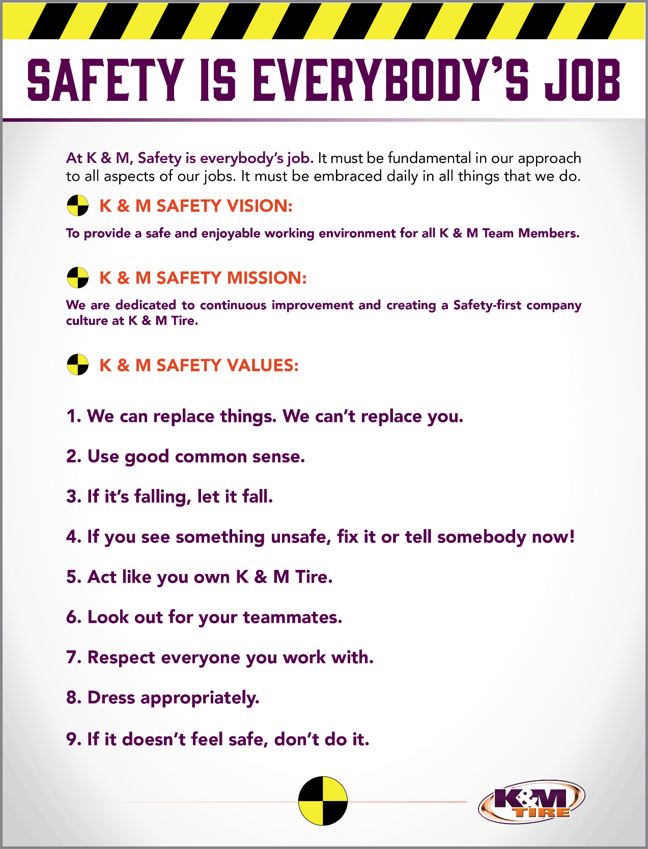

Important Company Information
This information is updated frequently. To ensure you are viewing the most current and accurate information, please use the links to access each document.

Employee Handbook
Employee Handbook can be found in Paylocity under Self – Service Portal then unemployment and is accessible HERE.

Organizational Chart
The organizational chart is a breakdown showing who is on each team and the chain of command throughout the entire company starting with the CEO and President. It is maintained on Paylocity and is accessible HERE.

Our Locations

Warehouse Locations - Contact Information
The Warehouse Locations – Contact Information is a Word document listing each of our warehouse locations’ addresses, a phone number to reach the warehouse/manager, the manager’s name and an email address for to reach the warehouse manager directly as well as a “location” email. When sending an email to the location email address, it will be sent to anyone associated with that warehouse who has an active email address. This list is maintained by our Human Resources department and can be found on the F: Drive. You can also view the list by clicking HERE.

K&M Tire US Footprint
Click on the below link to see the footprint map
http://kmtire.com/km-cgi/distmap

Car Dealer Sales Manager Manual Introduction

This manual is intended to provide helpful information for any person working in various Outside Sales positions with K&M Tire. It will be especially helpful for those newly hired or new to the Car Dealer Sales Manager position. There will be some step-by-step procedural suggestions. This manual, however, does not replace the necessity to work closely with your sales manager for guidance when needed.

Welcome
Welcome to the K&M Tire family and Outside Sales Team! We are pleased you decided to become part of our positive culture and strive to make our company the leading and most trusted tire distributor. Our #1 Value is to make the customer the most important person in our business, and that starts with you. We have many tools to help you along the way and we understand that it can be overwhelming in the beginning. Do not hesitate to ask for help; like family we are all here to support you.
In the Car Dealer Sales Manager position, you will manage your Outside Sales Team within your territory. It would be impossible to include everything in such a short letter. For this reason, we created this S.O.P. (Standard Operating Procedure) reference guide. We will keep this up to date when processes change, but remember if you have any questions, ASK. Welcome to the team and we look forward to sharing your success!

Providing Training, Leadership and Direction to produce maximum unit growth

Conduct CDS employee evaluations
- Periodic employee evaluations are a key component in effort to ensure employees are developing and are aligned with company goals.
- Minimally, annual evaluation of each employee should be completed. This is required by K&M, but also is necessary for any employee’s own development.
- New employees should receive 30-60-90 or 60-90-120 day evaluations at beginning of employment or start of new role. This helps to ensure the rapid development required in this period for the new employee.
- Evaluations should be made with transparency and honesty. Address any issues that need attention and make note of any worthy accomplishments as well.
- Evaluations should involve back and forth conversation with manager and employee. It is important that employees understand the “why” and that managers get feedback from employee.

Visit and make sales calls with the CDS or OSR at least once a month
- The CDSM needs to spend the time with CDS & OSR to foster the relationship. As teammates a good working relationship is a must and mutual respect as well.
- The CDSM should coach or mentor any sales rep when the need arises. Joint sales calls are great opportunities for evaluation of this potential need.
- The CDSM needs to understand what is going on with customers as well. Joint calls allow for the CDSM to stay in front of customers and hear what they say directly so that decisions that may need to be made can be done so with full understanding of facts on the ground.

Provide direction to the CDS on a daily, weekly and monthly basis
- Establish new customers and grow current customers.
  - The core job responsibility of anyone in Sales is to sell and grow those sales.
  - There is no “I” in team, and a team effort to find & develop customers is always more effective.
- The team effort has a side benefit, as it allows for the CDS & OSR to learn from what is offered by the CDSM
- Maintain and grow accounts without undercutting competitors pricing for off program car dealers.
  - K&M offers a very competitive overall value proposition to customers, part of which is pricing. There will be instances where price may need to be addressed.
  - The CDSM should be aware of competitor’s price strategies and service levels. Awareness doesn’t mean to focus on it. Understanding what they do can greatly help in any evaluation of need for price changes.
  - CDS & OSR should diligently follow the price level request process when they feel a price change is required to earn or maintain a customer’s business.
  - The CDSM should vet the PLR, including discussing with the OSR and potentially the customer. When CDSM determines the PLR is warranted it should be sent to local RSM and Director of Sales for approval.
  - After approval, it is responsibility of the RSM, CDSM, OSR & CDS to monitor the impact of the PL change and adjust further if necessary (including potential retraction). If the PLR is determined to not be warranted by RSM or is denied by the Director of Sales or VP of Sales the CDSM should work with CDS and or OSR to find a different path to follow with customer.

Be knowledgeable of and promote the products K&M has to offer.
- The CDSM needs a good working understanding of the tire industry and various segments and products. This is necessary for both the sales effort itself as well as the effort to coach teammates.
- The CDSM should understand the seasonality of certain products in the region that is covered.
- The CDSM should understand the levels of importance within the company for certain segments, products or brands that K&M offers.

Be knowledgeable of and promote the programs K&M has to offer
- The CDSM, as well anyone in outside sales, needs to have high level of understanding and completely support K&M’s in house programs.
  - Stay up to date on requirements for participation.
  - Stay updated on current promotions within the programs.
  - Maintain focus on K&M customers that participate in these programs

The CDSM needs to have working knowledge of K&M’s various vendor and partner programs.
- Stay in contact with the various vendor reps for the most current information on those programs.
- Ensure outside reps are aware of what promotions are happening with each program and that the promotions are being presented to customers and prospects.
- Work with the outside reps and vendor reps to ensure customers achieve at as high a level as possible on the programs in which they participate via K&M.

Be knowledgeable of and promote K&M’s Weblink 2.0
- Understand in detail how Weblink 2.0 works
- Be aware of how competitor sites work and what might be different with Weblink 2.0
- Stay up to date on changes with Weblink 2.0
- Work with outside reps and customers to utilize Weblink 2.0 to its fullest capabilities.

Work towards the BestOne motto of: give every customer a reason to smile (outstanding customer service)
- K&M Value #1 state to make the customer the most important person in our business.
  - Always keep customer satisfaction in mind.
  - Be aware of impact of decisions that you make
  - Don’t commit to something you cannot follow through on.
  - Don’t set yourself and K&M up to win for the customer whenever possible.
- Promote focus on customer service with our sales team.
  - Encourage steps by the OSR’s to go above and beyond when needed.
  - Foster the need to urgently accept accountability in times of stress and attitude to persevere from that stress.

Make it easy and convenient to do business with K&M Tire.
- CDSM should understand the coach the OSR & CDS to understand where K&M has advantages and where K&M may be at a disadvantage.
- Understand company policies and procedures. If you know where there is potential for trouble be proactive and work to prevent it.
  - Example would be signing up a new dealer that you know is located in area that is at the end of route the normally finishes at 3:30 pm. If the dealer tells you that getting tires early in the morning is necessary for them don’t just accept the app and move on. Be transparent with the dealer and explain what our level of service is so there are no surprises.

Evaluate and establish territories
- The CDSM is responsible for establishing the sales territory that the CDS covers.
  - The CDSM should consider the geographical size of the territory in conjunction with where the rep lives and what travel concerns might be in play.
  - The CDSM should consider any special needs of key customers for a given territory and what the expertise may be required for the assigned outside rep.
  - The CDSM can establish boundaries for sales territories (suggested there be some geographical continuity to territories) how it works best. Examples of how would be:
    - Defined by K&M routes. Easy to identify customers. New customers, especially on the borders of routes, and be difficult to designate. The routes change quite frequently.
- The CDSM should ensure that the CDS are familiar with the territory assigned and that the reps has some level of familiarity with adjacent sales territories.
- The CDSM should evaluate the CDS territories regularly. Questions to be considered would be:
  - Is the entirety of the territory be covered adequately?
  - Is the assigned CDS able to focus on the customers or areas of the territory deemed most important?
  - Would changes to territory assignments be beneficial to customers or reps or both?

Promote a team environment
- Lead by example. Whenever possible work with the OSR and CDS. Make the effort as collaborate as much as possible.
- Encourage teamwork at the outside rep level within the group. The positions are solitary in many ways, but the reps will be more successful working together when opportunities present themselves.
- Overtime leadership and mentoring roles will develop within the organization which can lead to development of a future manager.
- Encourage and promote “Teamwork makes the dream work” with everyone you come into contact within K&M Tire.
- A positive relationship between as many people within the organization as possible is very important. To continue to be the leading, most trusted, we must trust each other and work together to achieve continuous improvement.

Responsible for managing and resolving conflict in the work environment by using the company Values as a guide.
- Don’t be surprised that on occasion tensions flare up between teammates or with customers.
  - If conflict involves a customer, keep in mind the effort to make the customer the most important person in our business.
  - If you hold yourself to a high level of integrity and character these traits will show through as you endeavor to resolve conflict.
  - When these events arise, trying to nurture feelings of trust and respect between the parties involved with help to lessen chance of further conflict.
  - Sometimes conflict can be the result of good intentions on all sides. Encourage the effort to continually improve things.
  - When disruptions or tension arise over conflict you have a responsibility at that moment to help correct the situation. Furthermore, you have a responsibility to mentor teammates involved to recognize that they also have the same responsibility.
  - Don’t be afraid to get your hands dirty. You may have to dive into the situation and dig around to find out how best to help.
  - Don’t let yourself be the source of conflict. Bad habits can arise and you may not even recognize it is happening. Hints can show themselves, and this is good time for some retrospection. If you find a habit you have does lead to conflict then there is no time like the present to start working to change.
  - At the end of the day, everyone involved is not always going to be happy with final resolution to the conflict. The CDSM should work to make sure the resolution in fair to all parties as much as possible.

Assure that competent, good quality work is being done.
- K&M offers a number of tools that can help you in monitoring and evaluation of the work being done by outside sales reps.
  - Telenotes is a key tool that should be a part of your day every day.
    - Read the Telenotes the outside reps on your team leave each day.
    - Take note of the content of the various notes. You can get indications of where reps may need help from what is in the note.
    - Take note of the quantity of notes left. Not all sales territories are created equal, but you and your reps should have a good understanding of the number of calls per day, on average, that are required. If you need help in establishing a set number get with the VP of Sales for some instruction.
  - Use Logitrac to assist you in monitoring daily activity.
    - With Logitrac you can see if a rep is fully covering the assigned territory.
    - You can determine if too much or too little time is spent in given areas.
    - You can use to monitor daily start and stop times as needed.
    - You can compare to Telenotes to see if there are any discrepancies.
  - Use the various Intranet reports to track sales results.
    - These reports don’t tell much day to day, but overtime you can see trends.
  - Use GM, Ford, and Mopar Websites, Emails from manufacture reps and emails from auto Manufacture reps to track how much each dealer is buying on program.
    - Utilize ami.gmtirecentral.com for GM Dealers to track total units purchased on program vs. K&M purchases. You can also look up top selling tires by dealer and dealer rebate earnings.
    - Utilize atwdistributor.com to track Ford dealer earnings, program information and resources.
    - Utilize Goodyear sell out Mopar report that shows total units purchased on program vs. Goodyear.
- A good practice would be to have the CDS on your team forward any important documents like credit apps or program forms to you first, or at least, copy you in on these at time of forwarding.
  - You can inspect and ensure the forms are completed properly. This saves time for those in other departments.
  - You can coach the reps on your team on what I needed.
- Engage the reps on your team and outside sales in frequent discussions about their work.
  - Stay up to date on what troubles they be having with customers or programs.
    - Be proactive here, don’t wait for them to reach out to you.
  - Talk about what the rep does well. Let he or she know what you know about the successes and encourage more.
  - Collaborate on a game plan.
    - Being involved does not mean you are micro managing
    - Show that you care in the rep’s done
  - Foster a relationship with the reps where you can be made aware of any outside influences that impact the work being done.
    - Don’t be swayed away from showing that you care.

Present a clean, neat, professional appearance.

Work closely with K&M management
- Within the sales & Marketing department it is vitally important that you have good working relationship with VP of Sales & Marketing, Director of Sales, Marketing manager, Commercial Sales manager, Ag Sales manager, Car Dealer sales manager, Inside Sales manager and other Regional Sales managers.
- Actively seek opportunities to work together with managers in other departments. K&M’s success depends upon it.

Make good business decisions to help K&M be successful now and in the future.
- If you are not sure of which direction to go, seek out advice from other managers or VP of Sales.

Must support company goals
- Alignment with the direction the company is proceeding in is key
- Ultimately, we need to all pull in the same direction
- Promote this effort with the Outside Sales team and others

Manage CDS schedules and PTO
- Approve weekly schedules, time cards and PTO requests vis Paylocity.

Manage CDS expenses
- Approve monthly expense submitted via Concur
  - Coach employees when you see issues with expenses in regards to what is permissible and what is not as well as what might be excessive or unnecessary.

OE Connection
http://oeconnection.com/
- Log into OE Connection once a month to check for new Ford & GM dealers using K&M for replenishment business.
- Train CDS to look at OEC dealers using the D2D “My Dealers” tab

Sending out valuable emails to OSR & CDS to provide a clear goal / message.
- Use VLOOKUP to place K&M account # and sales data into tire manufactures and auto manufactures reports emailed. Priorities these reports based on value. We receive up to 20 reports per week, pick the ones that provide the most value, work with them and send them out to the reps.

Request current active AMI Dealer List & KM Feed info from IT – Monthly
- Using Route/Zip file F:\Logistics\Public\Route codes\Current weekly route update\1Routes and Frequency.xlsx use VLOOKUP to find dealers we are able to service by zip code. If N/A that means we do not service that particular zip code. You can delete any N/A at this time.
- Once you have the dealers we are able to service separated, use VLOOKUP against the AMI feed file (2nd tab) of the excel Chad sends. This will show you the dealers we have accounts with and are currently feeding. You can now delete those lines as well because you know they are feeding and setup correctly.
- The dealers left over should only be dealers we are able to service that do not have an account with us and or we are not feeding. You want to spend some time researching each line using the customer search portal on Intranet. http://intranet.kmtire.local/index.php?area=customersearch
  - Start your search by typing in the city
  - If it’s a common city name use the numbers of the address to check for an account with currently open at this address
  - If you do not find an account currently active proceed with filling out the PR form and getting them setup
  - If another dealer name or info is active at this address it usually means it was a buy/sell. Confirm this by using GM, Ford or Mopar reporting or Google.
  - The idea behind this is to ensure we are giving a good information to our credit department. Taking these steps prevents duplicate accounts being active at the same address.

Use the customer list to look for car dealers not properly categorized every 1 – 6 months.
- Car dealers are broken up into 4 categories G – GM, F – Ford, C – Chrysler and O – Other
- If a credit app is sent in and they do not indicate they are a Car Dealer, then it will may not show up on the ranking report if they start buying.
- To look for these errors.
  - Open the most recent customer list: F:\Marketing - Programs\Public\CUSTOMER LIST.xlsx
  - Highlight column H and select all categories other than G, F, C and O including blanks.
  - Copy and Paste the 6 month ranking report into a new tab
  - On the ranking report tab, delete all columns but Acct # and current units
  - Use VLOOKUP to match customer # to tire units and import to your Customer List.
  - Currently you should show customers not labeled as car dealers with tire purchases within the last 6 months.
  - You can go through customer name list by searching the excel for keywords like “FORD, GM, CDJR, AUTO SALES, MOTORS, CAR SALES, MOTORSPORTS, ETC.

Frequently Asked Questions
K&M instructions: Provide information on how the Warehouse Manager can get emergency assistance and system support (e.g., help desk support, inventory support, etc.). Include the names of the responsible personnel and organization(s), telephone numbers, and email addresses of the staff who serve as points of contact for system support.

Table 1 - Support Points of Contact
Contact / | Department | Phone | Email | Role
K&M Corporate Line | Corporate | 419-695-1061 | n/a

Appendix Revision History Tracking
The following table records information regarding changes made to the Operations Binder.

Table 6 - Revision History Tracking
Version Number | Date | Author/Owner | Description of Change
All | 9-9-2021 | Tom Schadl | Reviewed and fixed all Hyperlinks

